5.4 Solving Special Systems of Linear Equations p.226
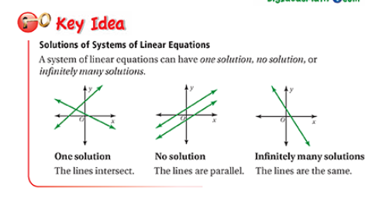
No solution: The equations will have the same slope (number in front of x when the equation is in slope-intercept form) which means they are parallel and will never intersect
Infinitely many solutions: The equations are exactly the same when in the same form (usually slope-intercept form)so they are literally the same line
One solution: neither conditions above are met and the lines will intersect at 1 point

Solve the following system of linear equations:
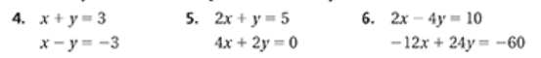

- no solution
- no solution
- (4, -3)
- (0,3)
- no solution
- infinitely many solutions

